**MYSURU ROYAL INSTITUTE OF TECHNOLOGY**

Lakshmipura Road, Palahally Post, SR Patna, Mandya – 571606

**DEPARTMENT OF COMPUTER SCIENCE & ENGINEERING**

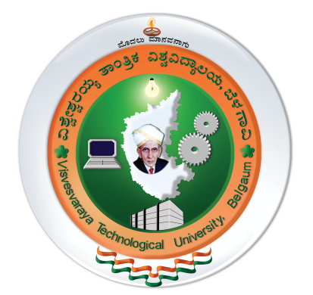

**CERTIFICATE**

This is to certify that the project on **“A DataAnalytics Approach to the Cyber Crime Underground Economy”** is a bonafide work carried out by **PRAJWAL H S** (**4MU16CS088**) of Eight semester Computer Science and Engineering as prescribed by Visvesvaraya Technological University, Belagavi, during the academic year **2019-2020**. It is certified that all the suggestions and corrections indicated for the internal assessment have been incorporated in the report deposited in the department library. The project report has been approved as it satisfies the requirements with respect to project work prescribed for the said degree.

|  |  |  |
| --- | --- | --- |
| ……………………………….  *Signature of the Guide*  **SOUMYA B,**  Asst. Prof. & HOD,  Department of  Computer Science & Engineering,  Mysuru Royal Institute of Technology, Mandya | ……………………………….  *Signature of the HOD*  **SOUMYA B,**  Asst. Prof. & HOD,  Department of  Computer Science & Engineering,  Mysuru Royal Institute of Technology, Mandya | ……………………………….  *Signature of the Principal*  **Dr. H.S.SURESH CHANDRA,**  Principal,  Mysuru Royal Institute of Technology, Mandya |

**External Viva-Voce**

**Name of the Examiner Signature with Date**

**1.**

**2.**